COSC 631 Database II – SPRING 2017
XML Project
Archanaben Patel ,Rebecca Akinlaja, Varsha Reddy
Deffination:
The purpose of an application project is to let students apply the XML data management technologies to a real life application. The application project requires implementation of a real life data exchange application using XML. Typically in such an application there will be two databases: a sender database and a receiver database. The application will convert the XML data stored in the sender database to relational format (this is called publishing data), and send the relational data to the receiver database. The receiver database needs to store the received data in structured format (i.e. in tables). The receiver database will also provide several query features that allow users to ask queries over the stored data. Figure 1 shows the architecture of the project.
Sender’s Database
XML Tables
Receiver’s Database
Relational Tables
Convert XML data in sender’s database into relational format
Store data in receiver’s database
Users can query data using SQL
Figure 1. The architecture of the project

Temp
Table
Note: In this project SQL*plus was used to create PL/SQL procedure to extract data from xml tables and the same platform has been used for create relational tables with corresponding attributes for each matching XMLtag.

Step 1: create two xml tables. With following code.
drop table CUSTOMERS;
drop table PRODUCTS;
CREATE TABLE CUSTOMERS
(
key_column1 VARCHAR2(10) primary key,
xml_column1 XMLType
);

CREATE TABLE PRODUCTS
(
key_column2 VARCHAR2(10) primary key,
xml_column2 XMLType
);

INSERT INTO CUSTOMERS
VALUES
('customer1',
xmltype('<Customer>
<Id>1</Id>
<FirstName>Joe</FirstName>
<Surname>Doe</Surname>
<contactnumber>111111111</contactnumber>
<age>25</age>
<gender>male</gender>
</Customer>'));
INSERT INTO CUSTOMERS
VALUES
('customer2',
xmltype('<Customer>
<Id>2</Id>
<FirstName>Mary</FirstName>
<Surname>Brown</Surname>
<contactnumber>2222222222</contactnumber>
<age>35</age>
<gender>female</gender>
</Customer>'));
INSERT INTO CUSTOMERS
VALUES
('customer3',
xmltype('<Customer>
<Id>3</Id>
<FirstName>Paul</FirstName>
<Surname>Smith</Surname>
<contactnumber>333333333</contactnumber>
<age>29</age>
<gender>male</gender>
</Customer>'));
INSERT INTO CUSTOMERS
VALUES
('customer4',
xmltype('<Customer>
<Id>4</Id>
<FirstName>mark</FirstName>
<Surname>williams</Surname>
<contactnumber>4444444444</contactnumber>
<age>51</age>
<gender>male</gender>
</Customer>'));
INSERT INTO CUSTOMERS
VALUES
('customer5',
xmltype('<Customer>
<Id>5</Id>
<FirstName>niyani</FirstName>
<Surname>Sharma</Surname>
<contactnumber>5555555555</contactnumber>
<age>37</age>
<gender>female</gender>
</Customer>'));
INSERT INTO PRODUCTS
VALUES
('product1',
xmltype('<Product>
<PId>1</PId>
<Name>Tea</Name>
<quantity>3</quantity>
<expirydate>2011-02-09</expirydate>
</Product>'));
INSERT INTO PRODUCTS
VALUES
('product2',
xmltype('<Product>
<PId>2</PId>
<Name>Cereals</Name>
<quantity>6</quantity>
<expirydate>2013-06-10</expirydate>
</Product>'));
INSERT INTO PRODUCTS
VALUES
('product3',
xmltype('<Product>
<PId>3</PId>
<Name>breads</Name>
<quantity>12</quantity>
<expirydate>2014-08-11</expirydate>
</Product>'));
INSERT INTO PRODUCTS
VALUES
(
'product4',
xmltype('<Product>
<PId>4</PId>
<Name>milk</Name>
<quantity>60</quantity>
<expirydate>2016-12-09</expirydate>
</Product>'));

INSERT INTO PRODUCTS
VALUES
(
'product5',
xmltype(' <Product>
<PId>5</PId>
<Name>coffee</Name>
<quantity>15</quantity>
<expirydate>2013-11-07</expirydate>
</Product>'));

Step 2: create two relation tables with following code.
drop table relational_customers;
CREATE table relational_customers(id varchar2(10),Firstname varchar2(10), Surname varchar2(10) , contactnumber varchar2(10) ,age varchar2(10),gender varchar2(10));

drop table relational_products;
CREATE table relational_products(pid varchar2(10),name varchar2(10) ,quantity varchar(10), expirydate varchar(15) );

Step 3: write two cursors for extract data from xml table and put into relational table.
Cursor1:
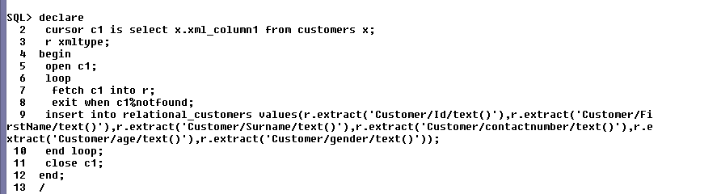
Cursor 2:
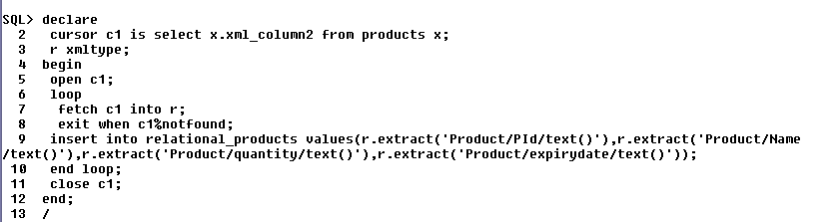

Step 4: now check the relational database table wheather data is inside or not with following query.

for relational customers table:
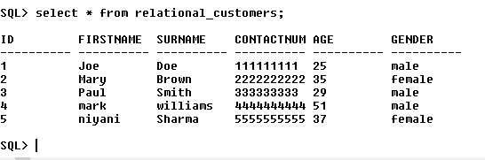
For realational products tables;
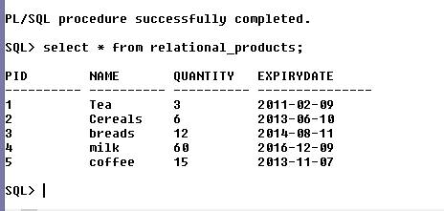

Conclusion:
In conclusion, I discovered that while a tempororary table was suggested it was not required,for the temporary table only served to insert the XML data into a table of XML type and PL/SQL procedure would query that table for the data it needs.it would be more realistic for the procedure to extract the data straight form the source, since the data types requiered are alredy known and also saving disk space ot accommodate the extra table in the database.

